# Exercise 1: CT Reconstruction

### Overview

* In this assignment you will explore the basic principles of image reconstruction in computed tomography (CT)
* filtered back projection and iterative reconstruction.
* You will use functions to convert an image into radon space and create a sinogram, a synthetic projection per radon or fanbeam (corresponding to parallel or fanbeam geometry respectively).
* Then utilizing those synthetic projections, you will reconstruct the original image.

### What to hand in for this assignment:

Submit your notebook solutions (code)+ written explanations/ descriptions in word/pdf.

### References

<https://www.youtube.com/watch?v=rKh_XIpsuc4> : General   
<https://www.youtube.com/watch?v=q7Rt_OY_7tU>: Sinogram

<https://www.youtube.com/watch?v=MA2y_2YySq0&t=3s>: Radon Transform  
<https://www.youtube.com/watch?v=pZ7JlXagT0w> : FBP  
<https://www.youtube.com/watch?v=r5ZIzog2JlE>

<https://www.youtube.com/watch?v=gu0lcxdFO1Q>: Algebraic reconstruction

<https://www.youtube.com/watch?v=moWou9zNl1w>: SIRT

<https://www.youtube.com/watch?v=YIvTpW3IevI>: Fourier Slice Theorem

### Steps :

**Step 1:**

* Create a head phantom or use the Shepp-Logan head phantom.
* The bright ellipse corresponds to the skull and the structures inside correspond to the various brain tissues and lesions.
* Calculate the synthetic projection using radon transform (parallel beam geometry) for the head phantom and the geometric images and explain your results.

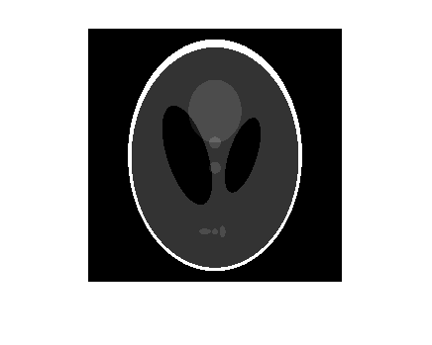

**Step 2:**

* Vary the number of projection angles (18,24, 90, ) and perform a reconstruction for each angle increment.
* Explain the effect of varying the angles.

**Step 3:**

* Demonstrate the difference of performing back projection and filtered back projection.

**Step 4:**

* Apply & describe an algebraic iterative reconstruction technique such as SIRT/ CGLS/ another.

**Good luck on Exercise 1!**

**Step1:**

* **Radon transform background:**
  + Radon transform of an image represented by the function $f(x,y)$ can be defined as a series of line integrals through $f(x,y)$ at different offsets from the origin.
  + The acquisition of data in medical imaging techniques such as MRI, CT and PET scanners involve radon transform, projecting a beam through an object.
  + For any non-homogeneous shape, Sinogram created by taking the radon transform at intervals of one degree from 0 to 180 degrees.
  + Each column in sinogram reconstructed image, is a projection for each degree between 0 to 180, depend on the degree interval.

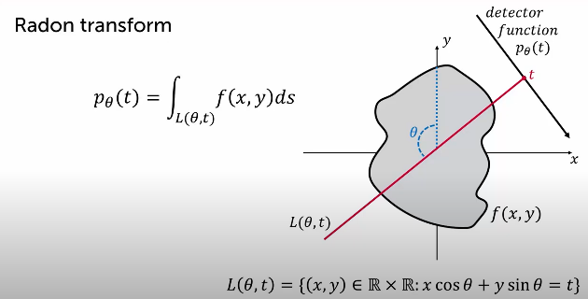

* + The reconstruction of object is dependent on the quality of sinogram, however all ray pass into the center of the non-homogeneous shape, therefore the center pixels will blur, to handle this phenomenon, it common practice to use a high pass filter is applied to the sinogram data in the frequency domain.
* **Sinogram generation:**
  + We load sinogram image in size (400,400)
  + We choose to divide the degree range into 400 degrees, in order the sinogram will be in the same image size.

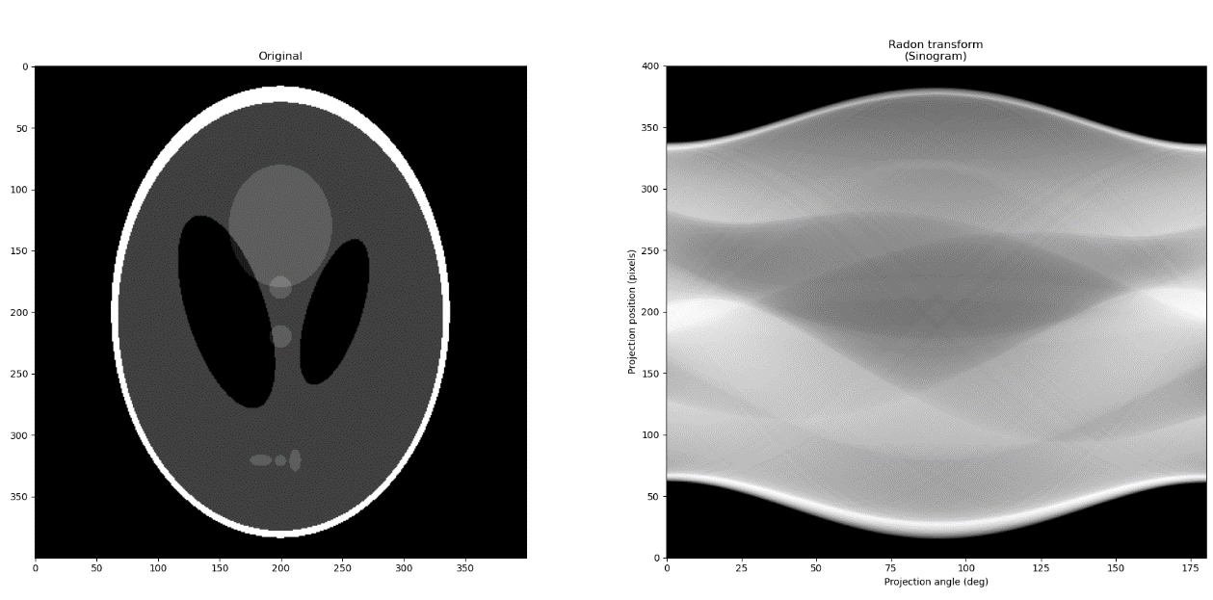

**Step2:**

* We test different number of projection angels, as we thought as number of projection angles decrease the sinogram image is less sharp, and more blurred.
* As we increase the amount of projection angles, the sinogram image it sharper, and smoother.
* Farther more the amount of angles, define the amount of columns, and the random transformation is slower.